The Playwrights
The three playwrights have been at the “reduced” approach for quite some time, yet each also has other experiences and interests. The following biographies have been adapted/edited from:

http://www.broadwayplaypubl.com/; http://www.reducedshakespeare.com/america.html

ADAM LONG

Adam lives in a little house in North London with his wife Alex, his son Joe, their friend John, and a stray cat who regularly attacks every member of the family. Adam is the proud holder of a British driver's license. He cites his influences as Harpo Marx, Dogen Zenji, and the Grateful Dead.
Although born in Manhattan and raised in California with Texans, Adam now resides in London with his lovely wife Alex, his seven year old son Joe and a small gray rabbit named Willard. He cites his influences as Harpo Marx, Suzuki Roshi and The Grateful Dead.

REED MARTIN
Reed Martin has written for the B B C, National Public Radio, Britain's Channel Four, R T E Ireland, Public Radio International, the Washington Post, and Vogue magazine. Prior to joining the Reduced Shakespeare Company, Reed was a Clown and Assistant Ringmaster with Ringling Brothers/Barnum & Bailey Circus for two years. He has a B A in political science/theater from U C Berkeley and an MFA in acting from UC San Diego. He lives in Northern California with his wife and son.

Mr. Martin co-created and performed in the original productions of The Bible: The Complete Word of God (abridged), The Complete History of America (abridged), Western Civilization: The Complete Musical (abridged), and All The Great Books (abridged). He contributed additional material to The Complete Works of William Shakespeare (abridged).
Mr. Martin is a managing partner of The Reduced Shakespeare Company and has performed at Lincoln Center Theater, London's West End, Kennedy Center, Seattle Repertory Theatre, American Repertory Theatre, Pittsburgh Public Theater, California Shakespeare Festival, McCarter Theatre, Long Wharf Theatre, Old Globe Theatre, La Jolla Playhouse, Alabama Shakespeare Festival, The White House and Madison Square Garden, as well as in 11 foreign countries. His voice was heard in the animated feature film Balto and just about every other part of him was seen in the British film Carry On Columbus.
With Austin Tichenor he co-authored the book The Greatest Story Ever Sold. His work has been nominated for an Olivier Award in London and a Helen Hayes Award in Washington, D.C. Mr. Martin is a member of the Dramatists Guild. He is a former professional minor league baseball umpire.

AUSTIN TICHENOR
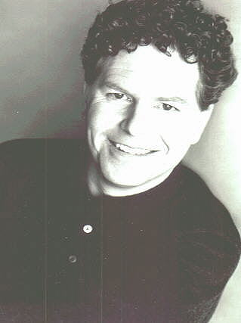

For the Reduced Shakespeare Company, Austin is also the co-author of the stage plays THE BIBLE: THE COMPLETE WORD OF GOD (abridged) and THE COMPLETE MILLENNIUM MUSICAL (abridged), the half-hour TV film The Ring Reduced, and the radio productions of The Reduced Shakespeare Radio Show (B B C), The Reduced Shakespeare Company Round Table (NPR's All Things Considered), and The Reduced Shakespeare Company Christmas (Public Radio International). He is also author of over twenty plays and musicals for young audiences.
Austin is a fifth-generation Californian born on the 54th anniversary of the San Francisco Earthquake and the 185th anniversary of Paul Revere's Ride, which makes him older than he looks but short for his weight. Since his debut writing and performing his boldly conceived kindergarten puppet show, Austin's interest in sticking his hands up the backsides of interesting characters continues to this day. An intellectual welterweight, Austin remains disappointingly average despite three very expensive degrees (two from UC Berkeley and one from Boston University). For seven seasons, he served as Associate Producing Director of the American Stage Festival in Milford, NH, writing over 20 plays and musicals for young audiences, as well as directing summer-stocky things like The Foreigner and Jesus Christ Superstar.
He's performed his own material on the BBC, National Public Radio, and England's Channel 4; other writings have appeared in the Washington Post, the Pittsburgh Post-Gazette, the New York Times Book Review, and the men's room wall of Spenger's Fish Grotto in Berkeley, California. As an actor, Austin plays recurring roles on 24 and Alias, and guest stars as “Guys In Ties” on any show with doctors or lawyers in it. Austin possesses a heartwarming spirituality and a delightful suspicion of organized religion; over the years, he's been an Agnostic (lapsed), a Pantheist (reformed), and now considers himself a Utilitarian (he believes in God when it's useful). This theological confusion is described in his book (written with Reed Martin) called The Greatest Story Ever Sold, available at blaspheming bookstores everywhere.

